**COSC344 Assignment 2**

**Team: 10**

**Leader: Hayden Knox**

**Members: Hayden Knox, Ava Reese, Katherine Butt, Samuel Lee**

**Original ERD Diagram**

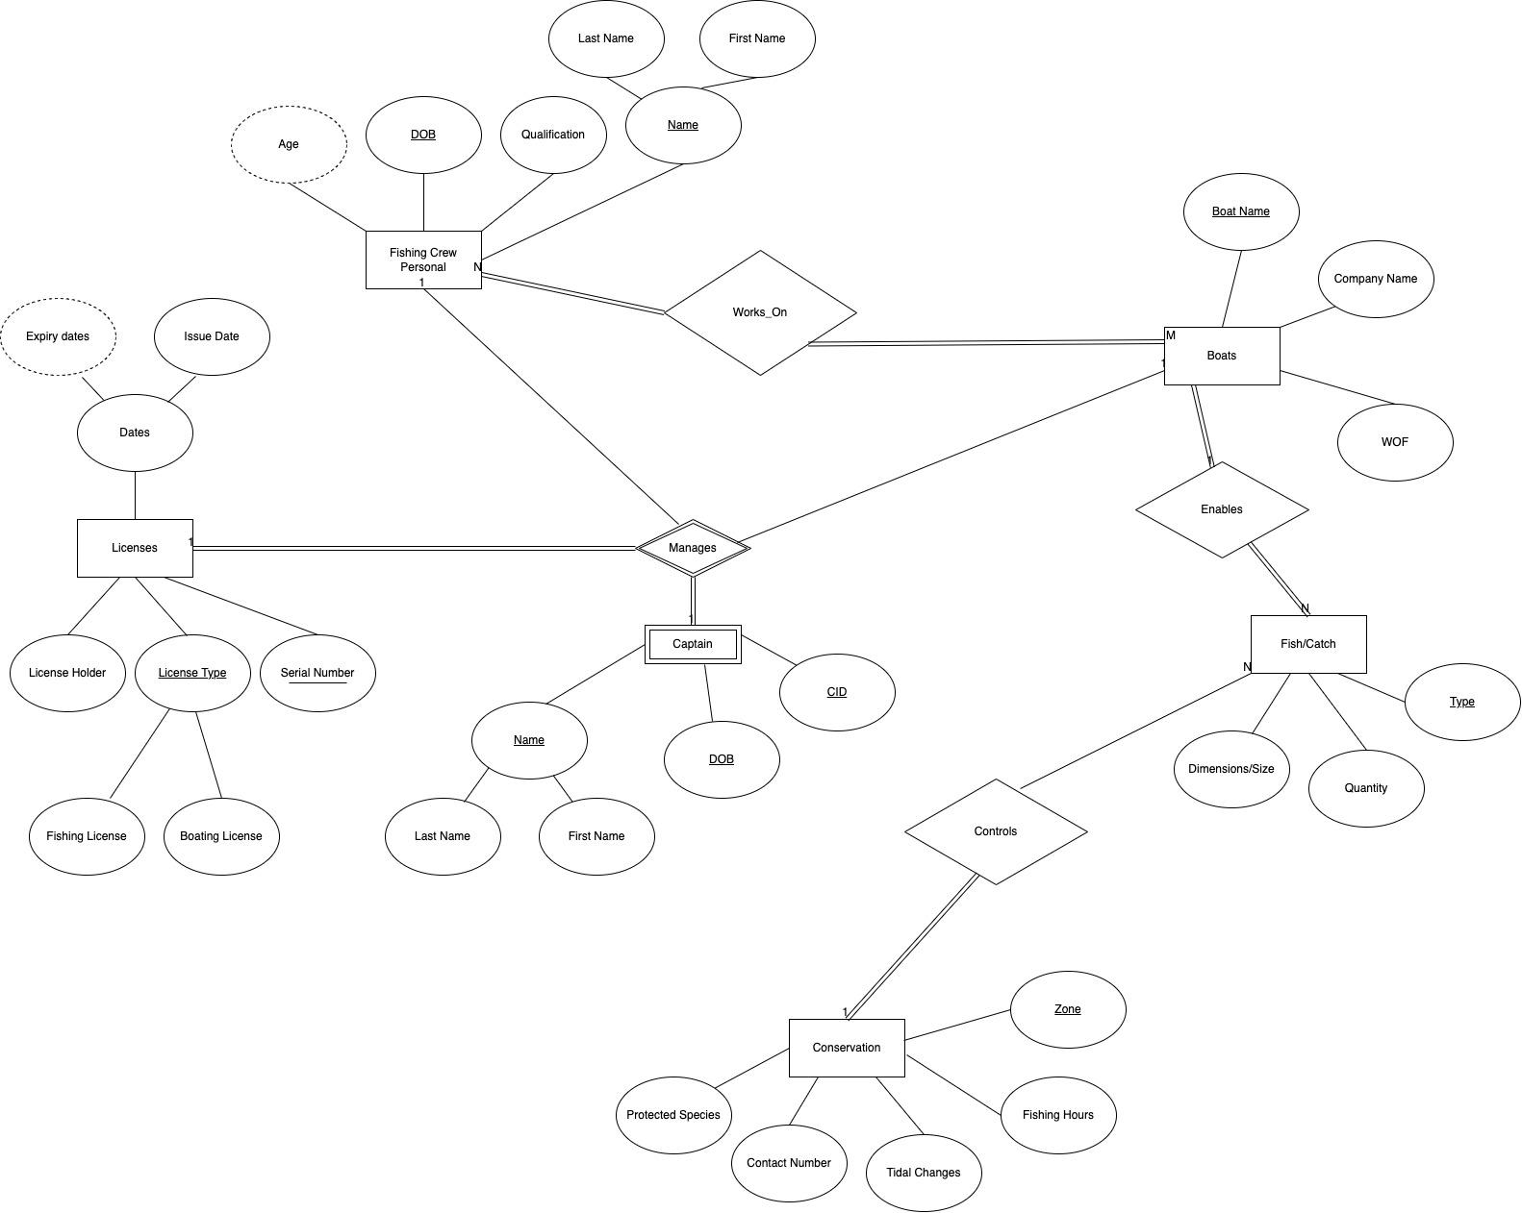

1. **Revised ER Diagram**

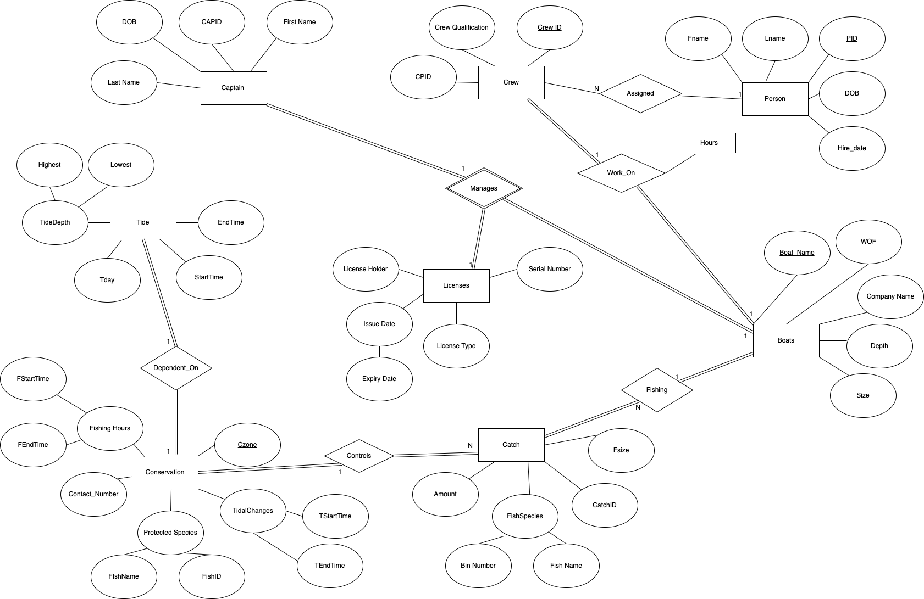

Changes Made:

* **Conservation Entity:**  
  The Conservation Entity had the most change. The changes made were to make attributes such as make many of the attributes into composite attributes. This change was applied to Fishing Hours, Protected Species, and the TidalChanges attributes.The aim of this change was to allow all the information required for each attribute to be stored in the best way possible so that all the information will be easy to access.
* **The Catch Entity:**  
  We added more attributes to the catch entity. These changes were made so that it allowed for each boat to catch more than one type of fish. Changes were also made to help make the attribute name clear such as changing quantity to amount. We also added in a new attribute called CatchID. This becomes the singular attribute for the primary key of the table. This also makes it easier to distinguish the different catches in the database. The Dimensions/Size attribute has been renamed to fish size and stores an integer value indicating the size of the fish.
* **The Tide Entity:**  
  This is a new entity type added. The purpose of this entity is to store the information relating to the different tide times on different days. This entity has a relationship to Conservation as the conservation zones are tide dependent.
* **Licenses Entity**  
  The licenses entity no longer has a composite attribute called dates. Issue date and Expiry Date are now both simple single valued attributes. The LicenseType attribute has also changed from a composite attribute to a simple single valued attribute. Different license types are denoted by a single character in the database.
* **Captain Entity**  
  The captain entity is no longer modeled as a weak entity type. This is due to it having attributes therefore it is now modeled as a normal entity type. The CID attribute has been renamed to CAPID however still serves the same person as the unique identifier for each entry. This also means that only one attribute is required for the primary key. Firstname and Lastname have been made simple single value attributes.
* **Crew Entity**  
  This is a new Entity. It takes the CrewQualification attribute from the FishingCrew entity in the original erd and also has a CPID and CrewID attributes. The aim of adding this entity was to allow for the data for individuals in each fishing crew to be stored separately. This we felt would make it easier to assign personnel to different crews. All the attributes for this entity are single attribute types and CrewID is the unique identifier.
* **Person Entity**  
  The person entity is also new. It takes the remaining attributes that the Crew Entity doesn’t from the original FishingCrew entity. The aim of this entity is to hold the personal information for each crew member. The hire_date attribute stores information relating to when a person was first employed.
* **Boat Entity**The only changes made to the boat entity was to add two new attributes called Depth and Size which relate to the overall size and depth of a boat.
* **Manages Relationship**This relationship now only occurs between the boats, license, and captain entities.   
  Captain to Boats is a 1:1 relationship because each boat can only have one captain and each captain can only control a single boat.  
  Licenses to Captain is a 1:1 relationship because each captain can only have a single license.  
  Licenses to Boat is a 1:N relationship because though each person on the boat can only have a single license each there can be many collective licenses on the boat.
* **WorksOn Relationship**This is a new relationship which connected crew to a boat. This is modeled as a 1:1 relationship because each boat can only have a single crew and each crew can only work on a single boat at any given time. This relationship also allows for a captain to be assigned a crew as both will be connected to the same boat. This was a fix made from the original ERD.  
  This relationship also has a weak entity type called hours. This entity stores the number of hours a crew has worked for.
* **Fishing Relationship**This has been renamed from enables in the original ERD as it is easier to understand what the relationship is allowing. The relationship is still a 1:N relationship and of mandatory participation.
* **Controls Relationship**This relationship has not been changed between the two versions of the ERD.
* **Dependent_On Relationship:**This is a new relationship between the tide and conservation entities. It has mandatory participation. It is modeled as a 1:1 relationship because each conservation area can only have a single set of applicable tides on at a single time.
* **Assigned**This is also a new relationship. It connects Person to Crew. It allows for individuals to be assigned into different crews. It is a 1:N relationship because each crew can have many persons assigned to it but each person can only be part of a single crew.

1. **Relational Schema**

Relational Schema Before Normalization  
Note: The relations are not shown on this schema as it has not been adjusted to account for normalization which accounts for most of the relationships in the sql.

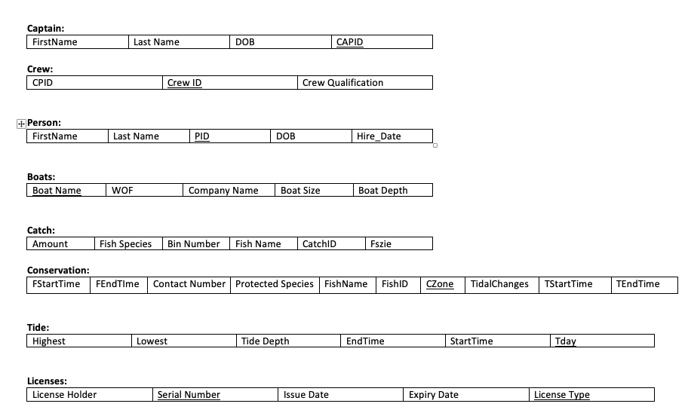

**4. Normalization**

**Captain table** automatically meets the requirements for BCNF format

**Crew table** automatically meets the requirements for BCNF format

**Person table** automatically meets the requirements for BCNF format

**Boats table** automatically meets the requirements for BCNF format

**Catch table** is not the correct format. This has occurred because not all values are atomic. Creating the following tables will allow for all values to become atomic and therefore meet the requirements for BCNF format.  
Catch1(Size, Amount, BinNumber)  
FishSpecies(FishName, BinNumber)  
The BinNumber attribute is used to connect the two tables together.  
  
**Conservation table** is not in the correct format because there are multivalued attributes. Creating new tables for each of the multivalued attributes will create the correct formatting.  
FishingHours(FStartTime, FEndTime, Czone)  
TidalChanges(TStartTime, TEndTime, Czone)  
ProtectedSpecies(FishName, FishID, Czone)  
Conservation1(Czone, Contact_Number)

**Tide** is not in the correct format because there are multivalued attributes. Creating a new table for depth will allow for all of the values to be atomic and therefore in the correct form.  
Depth(lowest, highest, Day)  
Tide1(Day, EndTime, StartTime)

**Licenses table** is in the correct format

After making these adjustments our miniwork is in the correct format to be made into a database.

**Relational Schema** after Normalization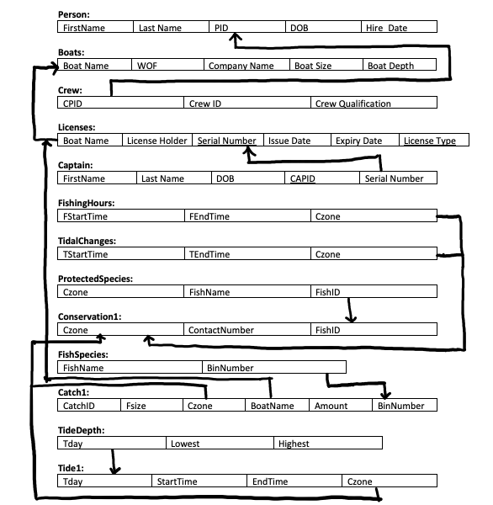

**5. Load.sql**

**DROP TABLE Captain;**

**DROP TABLE Licenses;**

**DROP TABLE Crew;**

**DROP TABLE Person;**

**DROP TABLE Tide1;**

**DROP TABLE TideDepth;**

**DROP TABLE Catch1;**

**DROP TABLE Conservation1;**

**DROP TABLE FishingHours;**

**DROP TABLE TidalChanges;**

**DROP TABLE ProtectedSpecies;**

**DROP TABLE FishSpecies;**

**DROP TABLE Boats;**

**CREATE TABLE Boats**

**(BoatName varchar(15) PRIMARY KEY,**

**CompanyName varchar(20) NOT NULL,**

**WOF DATE NOT NULL,**

**BoatSize int NOT NULL,**

**BoatDepth int NOT NULL**

**);**

**INSERT INTO Boats VALUES('THE BLACK PEARL', 'Far North Fisheries', TO_DATE('12-04-2023', 'dd-m\**

**m-yyyy'), 10 , 12);**

**INSERT INTO Boats VALUES('THE NAUGHTILLUS', 'Far North Fisheries', TO_DATE('12-04-2023', 'dd-m\**

**m-yyyy'), 20, 14);**

**CREATE TABLE Person**

**(FirstName varchar(30) NOT NULL,**

**LastName varchar(30) NOT NULL,**

**DOB DATE NOT NULL,**

**Hire_Date DATE,**

**PID varchar(10) PRIMARY KEY**

**);**

**INSERT INTO Person VALUES('Jack', 'Gold', TO_DATE('21-05-2001', 'dd-mm-yyyy'), TO_DATE('25-12-\**

**2005', 'dd-mm-yyyy'), '12344');**

**INSERT INTO Person VALUES('Jacques', 'Custeau', TO_DATE('21-05-1954', 'dd-mm-yyyy'), TO_DATE('\**

**12-03-1998' , 'dd-mm-yyyy'), 'FHJEF34');**

**INSERT INTO Person VALUES('Richie', 'McCaw', TO_DATE('15-02-1967', 'dd-mm-yyyy'), TO_DATE('24-\**

**07-1954','dd-mm-yyyy'), 'AOEKDMI');**

**INSERT INTO Person VALUES('Rango', 'Gold', TO_DATE('21-05-2001', 'dd-mm-yyyy'), TO_DATE('25-12\**

**-2005', 'dd-mm-yyyy'), 'YBHUE21');**

**INSERT INTO Person VALUES('John', 'Smith', TO_DATE('21-05-1990', 'dd-mm-yyyy'), TO_DATE('20-11\**

**-1999', 'dd-mm-yyyy'), 'FUBNDF4');**

**INSERT INTO Person VALUES('Pikachu', 'Random', TO_DATE('10-09-1999', 'dd-mm-yyyy'), TO_DATE('0\**

**1-02-2004', 'dd-mm-yyyy'), 'AMSD5MI');**

**CREATE TABLE Crew**

**(Crew_Qualification char(1) DEFAULT 'F',**

**CrewID varchar(8) PRIMARY KEY,**

**CPID varchar(10),**

**HoursWorked int,**

**CONSTRAINT fk_WorksOn**

**FOREIGN KEY(CPID)**

**REFERENCES Person(PID)**

**);**

**INSERT INTO Crew(Crew_Qualification, CrewID, CPID, HoursWorked) VALUES('T', '34TG42G@', '12344\**

**', 500);**

**INSERT INTO Crew(Crew_Qualification, CrewID, CPID, HoursWorked) VALUES('T', '6#RD##ED', 'FHJEF\**

**34', 1289);**

**INSERT INTO Crew(Crew_Qualification, CrewID, CPID, HoursWorked) VALUES('F', 'HSHFEWAD', 'AOEKD\**

**MI', 3000);**

**INSERT INTO Crew(Crew_Qualification, CrewID, CPID, HoursWorked) VALUES('T', '3432GRS@', 'YBHUE\**

**21', 750);**

**INSERT INTO Crew(Crew_Qualification, CrewID, CPID, HoursWorked) VALUES('T', 'JNIEUF!@', 'FUBND\**

**F4', 1349);**

**INSERT INTO Crew(Crew_Qualification, CrewID, CPID, HoursWorked) VALUES('F', '@2GHFAA1', 'AMSD5\**

**MI', 2040);**

**CREATE TABLE Licenses**

**(LicenseHolder varchar(20) NOT NULL,**

**LicensesType varchar(1) NOT NULL,**

**SerialNumber varchar(10) NOT NULL UNIQUE,**

**ExpiryDate DATE NOT NULL,**

**IssueDate DATE NOT NULL,**

**BoatName varchar(15),**

**PRIMARY KEY(LicensesType, IssueDate),**

**CONSTRAINT fk_manages**

**FOREIGN KEY(BoatName)**

**REFERENCES Boats(BoatName)**

**);**

**INSERT INTO Licenses VALUES('Jack Sparrow', 'A', 'QWERT123', TO_DATE('12-04-2023', 'dd-mm-yyyy\**

**'), TO_DATE('12-04-2022', 'dd-mm-yyyy'), 'THE BLACK PEARL');**

**INSERT INTO Licenses VALUES('Nemo Finding', 'A', '792A@WR', TO_DATE('12-04-2023', 'dd-mm-yyyy'\**

**), TO_DATE('12-04-2023', 'dd-mm-yyyy'), 'THE NAUGHTILLUS');**

**INSERT INTO Licenses VALUES('Jack Gold', 'C', 'DFHBE123', TO_DATE('12-04-2023', 'dd-mm-yyyy'),\**

**TO_DATE('12-04-2023', 'dd-mm-yyyy'), 'THE BLACK PEARL');**

**CREATE TABLE Captain**

**(DOB varchar(10) NOT NULL,**

**CapID varchar(8) PRIMARY KEY,**

**FirstName varchar(10) NOT NULL,**

**LastName varchar(10) NOT NULL,**

**SerialNumber varchar(10),**

**CONSTRAINT fk_licenses**

**FOREIGN KEY(SerialNumber)**

**REFERENCES Licenses(SerialNumber)**

**);**

**INSERT INTO Captain(DOB, CAPID, FirstName, LastName) VALUES(TO_DATE('12-05-1942', 'dd-mm-yyyy'\**

**),'792A@WR', 'Nemo', 'Finding');**

**INSERT INTO Captain(DOB, CAPID, FirstName, LastName) VALUES(TO_DATE('12-05-1968', 'dd-mm-yyyy'\**

**),'QWERT123', 'Jack', 'Sparrow');**

**CREATE TABLE FishingHours**

**(FStartTime DATE,**

**FEndTime DATE,**

**Czone int PRIMARY KEY**

**);**

**INSERT INTO FishingHours VALUES(TO_DATE('08:00:00','HH24:MI:SS'),TO_DATE('15:00:00','HH24:MI:S\**

**S'), 1);**

**INSERT INTO FishingHours VALUES(TO_DATE('19:15:00','HH24:MI:SS'),TO_DATE('03:20:00','HH24:MI:S\**

**S'), 3);**

**INSERT INTO FishingHours VALUES(TO_DATE('12:10:43','HH24:MI:SS'),TO_DATE('19:19:00','HH24:MI:S\**

**S'),2);**

**CREATE TABLE TidalChanges**

**(TStartTime DATE,**

**TEndTime DATE,**

**Czone int PRIMARY KEY**

**);**

**INSERT INTO TidalChanges VALUES(TO_DATE('09:36:10','HH24:MI:SS'),TO_DATE('19:36:10','HH24:MI:S\**

**S'), 1);**

**INSERT INTO TidalChanges VALUES(TO_DATE('14:19:50','HH24:MI:SS'),TO_DATE('03:19:19','HH24:MI:S\**

**S'), 2);**

**INSERT INTO TidalChanges VALUES(TO_DATE('22:00:00','HH24:MI:SS'),TO_DATE('12:00:','HH24:MI:SS'\**

**), 3);**

**CREATE TABLE ProtectedSpecies**

**(Czone int,**

**FishName varchar(25),**

**FishID int PRIMARY KEY**

**);**

**INSERT INTO ProtectedSpecies VALUES(1,'Marlin',1);**

**INSERT INTO ProtectedSpecies VALUES(1,'Starfish',2);**

**INSERT INTO ProtectedSpecies VALUES(2,'Starfish',3);**

**INSERT INTO ProtectedSpecies VALUES(3,'Blue Cod',4);**

**INSERT INTO ProtectedSpecies VALUES(2,'Dolphin',5);**

**CREATE TABLE Conservation1**

**(Czone int PRIMARY KEY,**

**ContactNumber varchar(10),**

**FishID int,**

**CONSTRAINT creatingFishingHours**

**FOREIGN KEY(Czone)**

**REFERENCES FishingHours(Czone),**

**CONSTRAINT creatingTidalChanges**

**FOREIGN KEY(Czone)**

**REFERENCES TidalChanges(Czone),**

**CONSTRAINT creatingProtectedSpecies**

**FOREIGN KEY(FishID)**

**REFERENCES ProtectedSpecies(FishID)**

**);**

**INSERT INTO Conservation1 VALUES(1,'080090800',1);**

**INSERT INTO Conservation1 VALUES(2,'080090801',1);**

**INSERT INTO Conservation1 VALUES(3,'080090802',2);**

**CREATE TABLE FishSpecies**

**(FishName varchar(25),**

**BinNumber int PRIMARY KEY**

**);**

**INSERT INTO FishSpecies VALUES('Squid',1);**

**INSERT INTO FishSpecies VALUES('Starfish',2);**

**INSERT INTO FishSpecies VALUES('Squid',3);**

**INSERT INTO FishSpecies VALUES('Marlin',4);**

**CREATE TABLE Catch1**

**(CatchID varchar(6) PRIMARY KEY,**

**Fsize int,**

**Czone int NOT NULL,**

**BoatName varchar(15),**

**Amount float DEFAULT NULL,**

**BinNumber int DEFAULT NULL UNIQUE,**

**CONSTRAINT fk_controls**

**FOREIGN KEY(Czone)**

**REFERENCES Conservation1(Czone),**

**CONSTRAINT fk_fishing**

**FOREIGN KEY(BoatName)**

**REFERENCES Boats(BoatName),**

**CONSTRAINT fk_species**

**FOREIGN KEY(BinNumber)**

**REFERENCES FishSpecies(BinNumber)**

**);**

**INSERT INTO Catch1 VALUES('abc123', 12, 1, 'THE BLACK PEARL', 19.8, 1);**

**INSERT INTO Catch1 VALUES('aabb19', 8, 2, 'THE BLACK PEARL', 15.8, 2);**

**INSERT INTO Catch1 VALUES('12naii', 1, 3, 'THE NAUGHTILLUS', 17.1, 4);**

**INSERT INTO Catch1 VALUES('acc123', 3, 3, 'THE NAUGHTILLUS', 10.3, 3);**

**CREATE TABLE TideDepth**

**(Tday DATE PRIMARY KEY,**

**Lowest float NOT NULL,**

**Highest float NOT NULL**

**);**

**INSERT INTO TideDepth VALUES(TO_DATE('19-01-2020','DD-MM-YYYY'),0.3,2.8);**

**INSERT INTO TideDepth VALUES(TO_DATE('03-12-2020','DD-MM-YYYY'),3.0,6.1);**

**INSERT INTO TideDepth VALUES(TO_DATE('29-05-2020','DD-MM-YYYY'),1.8,4.3);**

**INSERT INTO TideDepth VALUES(TO_DATE('08-03-2020','DD-MM-YYYY'),0.2,3.1);**

**CREATE TABLE Tide1**

**(Tday DATE PRIMARY KEY,**

**StartTime DATE,**

**EndTime DATE,**

**Czone int,**

**CONSTRAINT creatingTideDepth**

**FOREIGN KEY(Tday)**

**REFERENCES TideDepth(Tday),**

**CONSTRAINT fk_Dependent_On**

**FOREIGN KEY(Czone)**

**REFERENCES Conservation1(Czone)**

**);**

**INSERT INTO Tide1 VALUES(TO_DATE('19-01-2020','DD-MM-YYYY'), TO_DATE('12:30:20','HH24:MI:SS'),\**

**TO_DATE('01:40:10','HH24:MI:SS'),1);**

**INSERT INTO Tide1 VALUES(TO_DATE('03-12-2020','DD-MM-YYYY'), TO_DATE('10:30:20','HH24:MI:SS'),\**

**TO_DATE('23:19:00','HH24:MI:SS'),1);**

**INSERT INTO Tide1 VALUES(TO_DATE('29-05-2020','DD-MM-YYYY'), TO_DATE('19:12:00','HH24:MI:SS'),\**

**TO_DATE('09:01:00','HH24:MI:SS'),3);**

**INSERT INTO Tide1 VALUES(TO_DATE('08-03-2020','DD-MM-YYYY'), TO_DATE('10:30:20','HH24:MI:SS'),\**

**TO_DATE('23:19:00','HH24:MI:SS'),2);**

**COMMIT;**

**Teamwork summary:**

For assignment two we met up in the lab as a group to work through the different tasks. Katherine focused on correcting the original ERD diagram with the comments made from the previous assignment and modeled the relational schema diagram. Katherine, Ava and Hayden all worked together to complete the normalization section of the assignment. Hayden made a good start on creating the load.sql file and Ava and Katherine helped with debugging and error correction of the load.sql file so it could create a database successfully.

Though all group members attended as many meetings as they could not all members contributed to completing the assignment.